6COSC006W - Final Year Project Report

Contactless Voucher

Shouyi Cui (w1618594)

**Supervisor:** Barbara Villarini

BEng (Hons) in Software Engineering

School of Computing & Engineering

University of Westminster

Date: 13th July 2020

# Declaration

# Abstract

# Acknowledgements

# Table of contents

# List of figures

# Glossary

# Abbreviations

# Introduction

This chapter aims to give an overview of the context of this project, the problem is trying to resolve and the objectives.

## Problem statement

Nowadays there are many ways a retailer can reward the most loyal customers. There are loyalty schemes almost for everything, from the coffee shops to flights. The more money you spend with a company more likely they are going to offer you special discounts because it is easier and more convenient for the business (Jovancic, 2019).

The current most common type of loyalty schemes available in restaurant such as Starbucks, Pizza Hut, Domino’s require the customer to register online on their service and then download a mobile application (DevTeam.Space, 2020). Sometimes is the cashier that enables the digital stamp or other times is the record of the purchase in the customer account. Other smaller food restaurants usually have a classic paper card where the cashier can make a stamp on it. The cards are usually made with empty icons that can be filled with the stamp to represent the accumulation of number of purchase made.

Image sources:  https://www.tradeprint.co.uk/dam/jcr:a3f81a33-30e6-43c7-a798-6a9fdbf89a9b/comp_loyaltycard_170620_0187.jpg

https://www.thesun.co.uk/wp-content/uploads/2017/04/nero1.png



Figure . Paper loyalty card and loyalty Mobile App

In the example above (Figure 1.) on the left there is an example of paper loyalty card and on the right a mobile loyalty app. The concept is similar but the way it works is completely different because one is physical and other one is digital.

This project purpose is to enable something in between the two existing solutions by using the NFC (Near Field Communication) technology. Also known as contactless, this technology is now available in most of the devices in the world and it is becoming more popular.

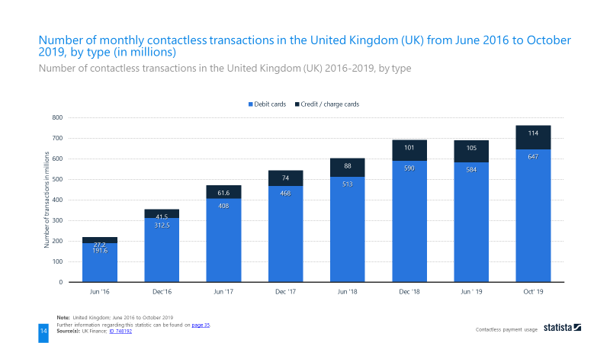

Figure . Monthly contactless transaction in the UK from June 2016 to October 2019

This technology is mostly used for payments with a small amount of money involved because it does not require any type of validation. The lack of validation makes the card more vulnerable to fraud (loveMoney, 2019), but that is a reasonable compromise for fast payments.

Moreover, in terms of ethic and ecologic point of view, this project has the potential to save the waste of plastic and paper by avoiding the demand of printed paper cards and plastic cards that “[…] have actually been the most requested gift in America” (Long, 2015).

## Aim and Objectives

The overall purpose is to create a Web App that uses the Web-NFC experimental feature on Google Chrome browser on mobile (Bhaumik, et al., 2020) and allows both customer and retailer to manage their loyalty experience the way they want.

The main scope is to allow the customer an easy way to collect stamps or points without the need of a mobile application. For the retailer the advantage is a system where the loyalty experience is not restrict to a proof a purchase, but it could a number of visits throughout a month or maybe an interaction with a new product in the store. With the use of NFC tag the retailer is also able to reuse the same piece of technology without investing into more complex machinery.

To achieve the desired goal, I will need to complete this list of objectives:

* Gain in-depth understanding on NFC capabilities
* Research NFC security known issues and always be aware on related news
* Develop a prototype to use as demo for stakeholders
* Constantly receive feedback from different sources to gain a wider perspective of the project
* Source control to make sure there is trace of the work done in case of work lost or not working as expected
* Time tracking and documentation of the work done for the project
* Deployment of the project on a stable environment such a cloud service
* Implement an algorithm that compress the small amount of data
* Work with an external API that can send a digital voucher to the customer

Moreover, I would like to achieve some additional features (in descending order of importance):

1. Creation of own images and logos
2. Customisation of the interface per type of user
3. Gamification of the user experience

# Background

This section introduces the literature of the project, a comparison of similar or relevant applications for the same customer reward. In addition, a discussion on the possible approaches for the intended solution is included.

## Literature Survey

Within the following sections the literature review will be uncovered to give an insight of the aspects of the NFC. Starting from the beginning of this technology and its original creator to the technical differentiation of the modern world. The modern enhancement and what are the future capabilities are also discussed within the scope of the project.

### The history and physics behind

A Russian physicist and inventor called Léon Theremin (also known as Lev Sergeyevich Termen) in 1920 developed a musical instrument, later named after himself, that can produce sounds without being touched. The theremin core principles are heterodyning and capacitance. The former is the result of a combination or mixture of two frequencies (a principle used for FM radios) and the latter is the “ability of a circuit to collect and store energy in the form of an electrical charge” (Fluke Corporation, 2020).

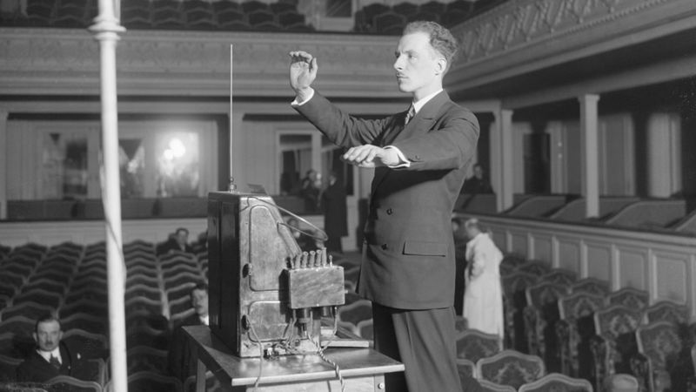

Figure . Léon Theremin playing his own invention

The electric instrument has two metal antennas, one to control the pitch and the other to control the volume. When a hand goes near to an antenna, a natural capacitor is generated, and its capacitance change based upon the distance to the hand. The circuit of the instrument takes the capacitance and set a frequency for the pitch and the volume. Then an inductor inside the instrument creates the frequency to be combined with the previous one so it can result with an interference that is hearable by the human hear (Huth, 2018).

Later, in 1945 the World War II finally came to an end. On the 4th August in Moscow a group of boys from the Young Pioneer Organization of the Soviet Union went to the American embassy to give a present as a symbol of friendship between the two countries. Averell Harriman, the United States ambassador at that time, took the great wooden ornament (Figure 4) as an important gesture and hung it on the wall of his office. They probably have checked every side of it to make sure it was not going to cause any harm like a Trojan horse, but nobody found anything alarming (Harford, 2019).

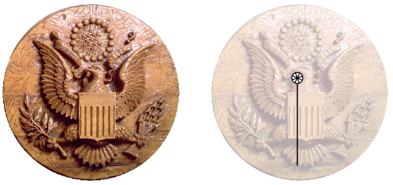

Figure . The present given to the US ambassador and the hidden device location

Eventually it was found out that the gift was an innovative creation from Theremin commissioned by his government to spy the conversation of the ambassador. It worked secretly for seven years until its discovery and gained the names “The Thing” and “The Great Seal Bug” (Harford, 2019).

The invention of Theremin consisted of a reverse concept of his musical instrument. He created a hidden circuit that had a capacitor that vibrated depending on the voice pattern. The capacitance would set the frequency representing the voice. An interference would be created when beaming a radio frequency signal to the object. This beaming would also power up and activate a response signal to broadcast out so it could be received and analysed to get the information needed (Crypto Museum, 2015).

This can be conceived as the first example of the modern RFID (radio-frequency identification) technology because of the concept and physics involved.

In fact, the underlying principle of RFID consists of electromagnetic waves and mutual inductance. The latter is a physical principle that describes how the change of current in a coil can produce an electromotive force (EMF) in an inductively coupled coil.

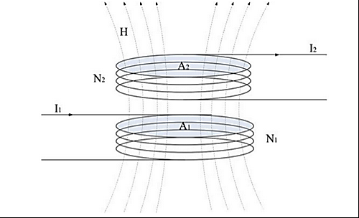

Figure . Inductive coupled coils

In the image above (Figure 5) we can consider $N_{1}$ to be an initiator that tries to engage to a target $N_{2}$. The mutual inductance between the two coils can be calculated by the following formula:

$$M_{12} = \frac{µ_{0}∙{H(I}_{1})∙N_{2}∙A_{2} }{I_{1}}$$

Being H the magnetic field strength, N the number of loops of the area A, and I the current that flows in the coil (Yang & Hancke, 2017).

### RFID (Radio-Frequency Identification)

RFID can be described as a form of wireless communication that uses the aforementioned electromagnetic principle (see 2.1.1) to uniquely identify an object (Rouse, 2007). It is purposely designed for identification because the RFID tags can hold only a small amount of data, usually around a thousand bytes or less (Igoe, et al., 2014).

There are two RFID types of communication mode: active and passive. But first of all, it is essential to define the two actors involved in the exchange: the target and the initiator. The initiator is the device that tries to read or write a tag, it generates the radio field and waits for responses from any target in the field. The target is usually the tag, that will respond with an UID (Unique Identifier Number) to the radio field (Igoe, et al., 2014). Therefore, the communication mode is considered as:

* *Active* when the target is powered independently (e.g. From a battery).
* *Passive* when the target has no power source. It usually gets the power from the radio field. Very similar to “The Great Seal Bug” (see 2.1.1).

At this point, it is worth mentioning there are various type of RFID protocol standards, usually developed by the ISO (International Standards Organisation) along with the major participants in the market. The different standards can change in terms of radio frequencies used (i.e. A lower frequency usually means a shorter read range), data format and data transfer rates (Lowry Solutions, 2014). These protocols are created for the purpose of having interoperable standards so that the technologies can work together and allow a competitive market from different industries (Igoe, et al., 2014).

### NFC (Near Field Communication)

NFC, similarly to the RFID, is also a wireless communication that works on the same physics principles mentioned before (see 2.1.1). It is designed upon the RFID protocols and it is generally possible to interact with the RFID tags (e.g. ISO-14443A tags are compatible with NFC). Its main role is to enable the target and the initiator to communicate by an exchange of meaningful data. This data can be either the capabilities of each other, records or even credentials.

It is important to note that NFC targets are not limited to tags, they can be also programmable devices like smartphones. There are two communication mode exactly like in the RFID: active and passive (see 2.1.2). Moreover, there are three operating modes:

* *Reader/Writer* when a device reads data from a target and/or writes to it.
* *Card emulators* when a device acts like a RFID tag in the electromagnetic field of another NFC or RFID device.
* *Peer-to-peer* when two devices exchange data to each other.

### Comparison between RFID and NFC

NFC can be considered as an enhanced version of RFID in the case where the initiator and target are in a short range. NFC is not designed to work the in long range so this limitation cannot be considered a real disadvantage, besides Wi-Fi and Bluetooth technologies are supposed to cover that gap.

Listed below are the common usage of the two technologies (Figure 6).

Image source: https://www.ecom-ex.com/fileadmin/_processed_/5/f/csm_17-02-07_RFID-NFC-final_153b8e3d75.jpg


Figure . RFID & NFC comparison

A big advantage of NFC is that it has a very low cost in comparison to the RFID, an NFC tag usually cost less than a pound (e.g. NTAG213, NTAG215, NTAG216). The long range advantage of RFID requires the target to be an active tag, and that is where the cost rise. Currently, every single RFID active tag can cost from £25 to £100 depending on the range required. The RFID reader is also very expensive costing from £150 to £1800 also depending on the range required (NextPoints, 2020). On the other hand, NFC readers can cost something around £40 but given that the number of smartphones with the NFC enabled are constantly increasing in numbers, maybe there is not even the need of an additional purchase.

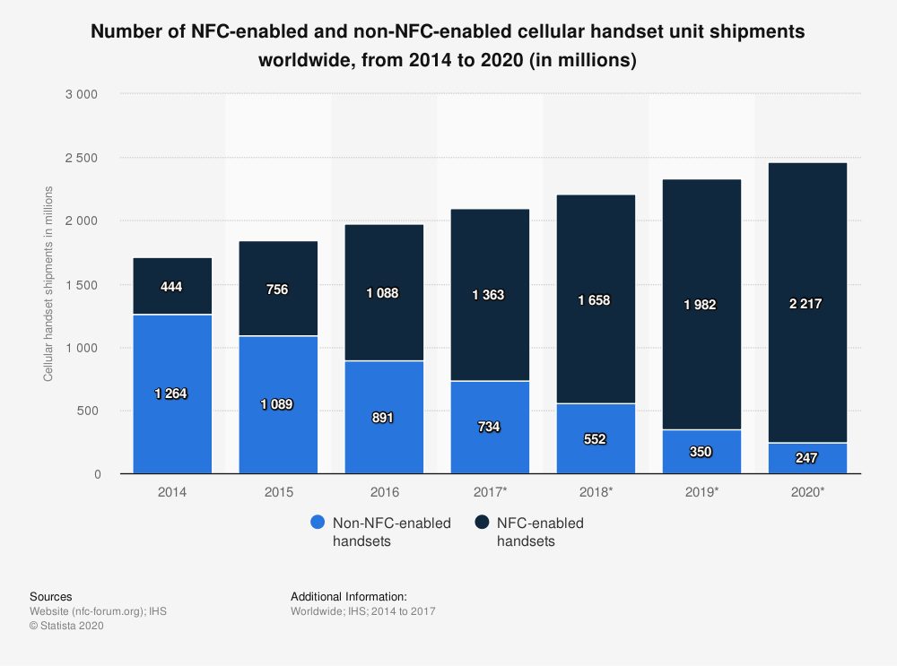

Figure . NFC enabled handsets from 2014 to 2020

In the figure shown above (Figure 7) it is possible to see the change over time of NFC enabled smartphones shipped in the world. Although this graph does not represent fully the numbers of all the smartphones in the market, it is fair to assume there is a similar trend because what changes is only the device delivery system.

In 2014 only the 25.99% handsets had NFC. Two years later, this feature increased in availability reaching 54.98%. Now in 2020, that percentage had rose to 89.98% and it is most likely to grow over time (Kenneth Research, 2020).

### NDEF (NFC Data Exchange Format)

NDEF is a data format operating across all NFC devices. A common NDEF message contains one or more NDEF records. Each of this record has its own UID, record type, length and payload of data (Igoe, et al., 2014).

A generic record is represented in the figure below (Figure 8).

Image source: 
https://w3c.github.io/web-nfc/#the-ndef-record-and-fields

Figure . NDEF record structure

* Bit 0-2 indicates the format of the type name.
* Bit 3 indicates the presence of an ID length field.
* Bit 4 indicates a short record.
* Bit 5 indicates whether the payload is chunked across multiple records.
* Bit 6 indicates whether this record is the last in the NDEF message.
* Bit 7 indicates whether this record is the first of the NDEF message.

This is the list of the NDEF record types:

1. **Empty NDEF** (TNF 0) as the name suggest it represent a record with no data and therefore Type Length field, ID Length field and Payload Length field must be 0 and the last three optional fields (Figure 8) must not be present.
2. **Well-known** (TNF 1) which is a set of sub record types standardised by the NFC forum such as text, URL, media and smart posters and handover options.
3. **MIME** (TNF 2) stores binary data with the associated MIME (Multipurpose Internet Mail Extensions) type.
4. **Absolute-URL** (TNF 3) contains the string of the full address that includes protocol and domain name.
5. **External** (TNF 4) is a Uniform Resource Name (URN) with the application data type (e.g. *urn:nfc:ext:domain.org:atype*).
6. **Unknown** (TNF 5) is for storing data that have incomprehensible data and are not associated with a MIME type. The application may assume the latter.
7. **Unchanged** (TNF 6) is a section of a chunked data set, so the payload is spread across multiple NDEF records.
8. **Reserved** (TNF 7) which means reserved by the NFC Forum for future use.

Image source:
https://w3c.github.io/web-nfc/#the-ndef-record-and-fields

Figure . Summary of possible Type Name Format (TNF)

### Web NFC

Web NFC is currently an experimental feature which overall goal is to give online sites the ability to read and write NFC tags in a secure and privacy preserving manner (Beaufort & Kenneth, 2020).

At the moment, this technology is limited to NDEF and is available as an original trial in Chrome v.81 until Chrome v.84 (Chrome Origin Trials, 2020) on Android OS smartphones.

The functionality can be enabled in the flags section (<chrome://flags/>) under the name “Experimental Web Platform features”. After the enabling, when surfing on the internet, if there is a Website that wants to use NFC features for the first time it will prompt in the page a request to use it. It is also going to prompt a message asking to turn on the NFC on the device in case it is off, while is not going to show anything if the feature is not compatible with the device (e.g. iOS smartphones).

Image source:
https://storage.googleapis.com/support-forums-api/attachment/thread-13605645-4739816311749951377.jpg

Figure . Example of quick dropdown settings of an Android device with NFC

This new enhancement released on January 2020 gives the developers a lot of new potential development in various use cases (Kostiainen, 2019).

The benefit of the NFC along with an ad hoc Web Application can improve the UX (User Experience) by making the user interact with the surrounding environment (e.g. treasure hunts).

## Review of Projects / Applications

In the following sections, the research on existing projects or applications relevant to the NFC and the intended project implementation will be presented.

### Google Pay

Google Pay has a mobile application that links to the user payment information to create an online payment system and digital wallet. It was developed by Google in 2015, known initially under the name of “Google Wallet” and later merged with “Android Pay” (Nieva & Bennett, 2018). There are many features in the application such as image recognition, credit and debit card validation but those are not relevant to the scope of this project.

There are two aspects relevant in the e-wallet. First, the loyalty card system that asks the user to add the details of a physical card of the store by either camera scansion or manual enter. After the card details are successfully added in, the app generates a barcode representing the loyalty card. Secondly, the NFC payment system that uses the HCE (Host Card Emulation) to recreate a previously added credit card to make a payment at the POS (Point Of Sale). Note that the app does not send exactly the card details but instead it uses a one-time security code that represents the user account information (Popper, 2015).

Advantages:

* Fast service.
* Secure and reliable.
* Automatic scansion of the card details by mobile camera.
* Unlimited payment amount, although some merchant applies the limit of £30 (Revolut, 2020).
* Available on Android devices running Lollipop 5.0 (released on June 2014) or higher.
* Does not need internet connection from the user point of view.

Disadvantages:

* Limited by the type of card issued by the bank.
* Restricted to Android OS and therefore not available on iOS devices. Considered as disadvantage because from a software development point of view it could mean two different implementations.
* Requires the store or retailer to have a specialised NFC reader that is not ideal in places like street food markets.

### Apple Pay (iPhone Wallet)

Apple Pay is also a payment system that has a mobile application as digital wallet that can be used for store payments. Fundamentally is the same concept of Google Pay. It was initially created for online payments only and later developed the feature of HCE to work at the POS.

Advantages:

* Fast service.
* Secure and reliable.
* Automatic scansion of the card details by mobile camera.
* Available on the Apple devices from iPhone 6 (released on September 2014) onwards and Apple Watches. Some iPads can have the software application but they are unable to process the NFC in-store payment, hence it used for online payments only (Hill, 2020).
* Payment amount is usually unlimited but that depends on the country and the merchant (Apple, 2020)
* Does not need internet connection from the user point of view.

Disadvantages:

* Limited by the type of card issued by the bank.
* Restricted to iOS and therefore not available on Android OS devices. Considered as disadvantage because from a software development point of view it could mean two different implementations.
* Requires the store or retailer to have a specialised NFC reader that can be is not ideal in places like street food markets.

### Other digital wallets and payment solutions

Since there are many other digital wallets like Google Pay and Apple Pay currently having the NFC payment method or QR loyalty system, those are just going to be briefly mentioned as a proof of the increased demand and popularity of this technology solution.

#### Samsung Pay

Like Google Pay concepts, but with the difference that is enabled on Samsung devices only. It adds the ability of the MST (Magnetic Secure Transmission) that other e-wallets do not have (Whitwam, 2020). Released on August 2015 and available on most devices from Galaxy Note 5 onwards (Savvides & Orellana, 2019).

#### Microsoft Pay

Identical models as the previously mentioned e-wallets. The only difference is that is designed for Windows OS and the feature on mobiles has been withdrawn on 29th February 2019 (Thorp-Lancaster, 2019).

#### WeChat Pay (service inside WeChat)

Similar to the previous payments systems but with the difference that the NFC capability is not popular in the stores because of the Chinese market. It is, in fact, used occasionally in the Chinese underground turnstiles (Borak, 2019). It is far more common the use of the QR (Quick Response) code as quick payment identification between users. The store does not need a POS anymore but instead it uses a smartphone or sometimes just a printed QR code. The scenario in a usual store transaction between customer and retailer are as follows:

1. Customer scans the retailer QR code.
2. Customer enters the money amount.
3. Customer validate transaction by either code or fingerprint
4. The app sends instantly the credit to the retailer.

Otherwise another option is:

1. Retailer scans customer QR code.
2. Retailer requests a payment to be sent via chat to the customer
3. Customer confirm transaction by code or fingerprint.

This solution is incorporated within the WeChat app that is available in all devices but Windows Phone (discontinued in 2016) and it also allows in-app store and web payments for loyalty schemes (Henriot, 2019). This app is popular among Chinese customers only (Borak, 2019), therefore out of the intended market of this project.

#### PayPal Wallet

Close to the aforementioned ideas, PayPal have developed this application to allow PayPal customers to pay using the QR code in the stores. This implementation released on May 2020 allows similar payment method as WeChat Pay, regarding the NFC aspect they rely on a Google Pay partnership (Smith, 2020).

#### Alipay Wallet

This company service needed to be commented due to the popularity and the high usage around the world. Alipay is considered to be the leading mobile payment platform but it does not have any NFC capability because solely based upon the QR code system (Heggestuen, 2014). It has a loyalty programme, but it works only with payments within the app (Basu, 2018).

#### Loopy Loyalty - PassKit

Loopy Loyalty is a web-based application part of the PassKit company solutions. It allows retailers to create a customised loyalty scheme by adding own brand images and colour palette.

The service offered works as loyalty card to be stored in Apple Wallet or Google Pay. An example of user journey case is:

1. The customer is registered in the loyalty scheme by email prior to the payment process.
2. The customer buys a product and therefore satisfies the stamp collection criteria (to be decided by the retailer).
3. The customer shows the QR code on its digital wallet that represents his details.
4. The retailer scans within the Loopy Loyalty Stamper mobile application the customer QR code.
5. The retailer has the option of choosing the number of stamps to give and redeem rewards if available (see Figure 11).
6. After the retailer has confirmed the options selected, the customer will have the loyalty card details updated.

Immagine screenshot source:
https://lh3.googleusercontent.com/CqPgAtSTKal-DProv1_xMobPhcA_jYlyAM4IZ4005p-bqhew2_v2EFLB6Lq1NOwpwA=w3068-h1444

Figure . Options for stamp record on Loopy Loyalty Stamper app

Although this system is very efficient, in practical terms, it is hard to use. The retailer would need to have his smartphone available all the time after a transaction is successfully completed. He would also need some time to interact on the smartphone to decide all the options for the customer. It increases the responsibility for the cashier and the time process for each customer.

### Embargo

Embargo is a mobile application where there are rewards scheme for people who often go to social places such as pubs and restaurants. The app is also available in various food market sites and it just requires the user to register into their service with no bank details.

The app gives rewards based upon the number of visits the customer accrue over time in the same place, like a classic loyalty scheme. A certain number of visits allow the customer to redeem rewards at the venue. Some special discounts are also included depending on the specific place.

As shown below (see Figure 11), the app has a very simple interface with few buttons and icons that result in a simple user experience which is very important for this type of service.

Image source: https://play.google.com/store/apps/details?id=com.embargoapp.app&hl=en_GB


Figure . Embargo App screenshot example from the Google Play Store

This case is different to the previous because there is not either NFC or QR code involved. Instead, there is beacon technology that requires the use of Bluetooth connection. To locate better the customer position in relation to the venue the app also requires GPS (Global Positioning System) to be enabled (Embargo Lifestyle Limited, 2020).

Advantages:

* No need of user personal details such as bank cards.
* It works similar to the NFC, but it uses Bluetooth, GPS and Wi-Fi.
* Complete user journey to bring more customer to the venues.
* There is an ability to automatically connect to the venue Wi-Fi network.

Disadvantages:

* The user must have Bluetooth, GPS and Wi-Fi enabled in order to work.
* Relies on a good internet connection environment which can be troublesome in a very crowded place.

#### Beacon Technology

The beacon technology is the closest alternative to the RFID and NFC use case scenarios. It uses the consolidated Bluetooth technology to send signals in the nearby in the form of UHF (Ultra High Frequency) radio waves around 2.45 GHz (Author, 2020). Like to the RFID active mode (see 2.1.2) it requires both ends to have their own power source but it can send more data, like in the NFC(see 2.1.3). It is designed to work in a short or medium range around 10 to 30 meters although it has the capability to reach 300 meters. In terms of cost and availability it loses many points because it is very hard to get one and the cheapest transmitter, a keychain beacon, costs around £20. The price rises to around £40 for longer ranges (Ratna, 2020) that makes it more limited depending on the companies budget.

### Jisp

Jisp is a company that provides a mobile application where you can buy products in selected retailers by using only NFC feature in the smartphone. The user must register with a payment system like a bank card in the app to start purchasing products. A possible use case can be described as:

1. The customer is registered to the app and has the payment method set up.
2. The customer goes to the shop that have special tags for the products on the shelves.
3. Whenever the customer decides to pick a product, he scans the tag of the product to add it in the basket.
4. Once the customer has finished the choose the products, he goes to a checkout.
5. The checkout is another NFC specialised tag that completes the purchase by making the payment with the stored card details.

Advantages:

* Built around the NFC but it also can scan QR codes.
* User can use the app also to find information related to the product scanned.
* Can monitor user behaviour to customise what they may want.
* Gamification service to engage with the user such as quizzes.
* Does not require the user to register for using some features such as scanning product details.

Disadvantages:

* Requires an account with debit card set up.
* It is necessary to have a customised shop with their service and technology, therefore the availability is limited.

### Branded loyalty apps

This section covers an overall overview of the existing loyalty mobile application available from different brands such Costa Coffee and Tesco. It is focused on Caffè Nero as main example because the most similar to the intended implementation.

The difference between the following services is that they are developed by the retailer itself. They do not work as medium between retailer and customer; they are the direct seller of the product and the app user can only be the customer.

#### Caffè Nero App

The coffee house company based in London have their own loyalty scheme reward system on a mobile application as well as the paper card version (see Figure 1).

The paper stamp card is like the other popular versions of it. The customer buys a coffee and earns a stamp as a form of loyalty point. After collecting ten stamps, the customer is rewarded with a free coffee. Usually is the cashier that marks the stamp on the card.

The other digital version provides the same service but on the smartphone. Instead of the cashier stamping on the card, he scans the QR code that the customer shows to him. It is possible to ask the cashier to transfer the existing stamp from the paper card to the app (Caffè Nero, 2019).

This product has the same results of the goal of this project. The difference is in the technology used, this project has the intent to use NFC and avoid the customer to download any app.

Advantages:

* Flexibility of choice for the customer between paper or digital card
* Does not require and bank card associated with it although it is possible to add it, so the customer can earn the loyalty stamp and pay at the same time (Caffè Nero, 2019).
* The voucher awarded is kept separately, so the user can continue collect new stamps.
* It can be added to the Apple Wallet or Google Pay to collect stamps.
* It only requires an email address and a password to register.
* Does not require the user to be connected over the internet to collect the stamp.

Disadvantages:

* Must be scanned prior to the purchase.
* Can be used only within Caffè Nero shops.

#### Others

To avoid redundancy of the content, a table of other popular loyalty mobile app that are available in the UK territory is listed below:

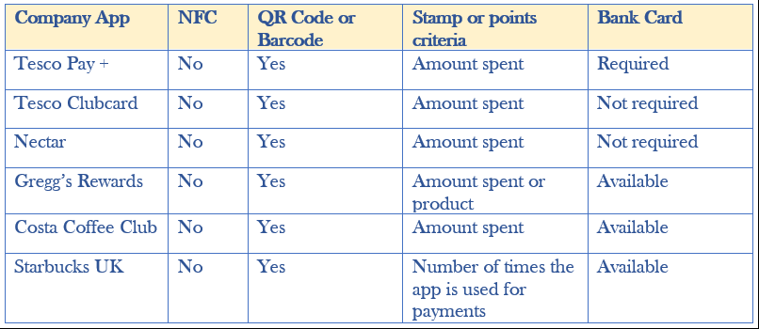

Comparison of company mobile loyalty apps features and loyalty scheme details

From this overview (see Table 1), it is clear that the NFC technology is still not used for loyalty schemes. In the Tesco Pay + case, the loyalty point collection is incorporated within the payment solution so the customer does not need to do additional scanning or verification because it is automatically done within the company services (Tesco, 2020).

Gregg’s Rewards and Costa Coffee Club are relatively similar to the Caffè Nero scenario (see 2.2.6.1) while Starbucks is different. The latter rewards the customer if paying using a pre-loaded Starbuck Card that can be added into the app.

## Review of tools and techniques

# Requirements

## Stakeholders

## Gathering requirements

After a conversation with the CEO, Julian Fisher …

Conversation with Toby and David

Emails with people from GitHub

Other students

## Modelling requirements and relevant diagrams

## List of project requirements

## Legal, social and ethical issues

# Methodology

# Design

How the project design is implemented and the tool used

UI interface

Landing page for registration

Customer scheme

Retailer settings

# Tools and implementation

## Tools

Programming languages, libraries, framework with choice justification. Razor pages

### Visual Studio MVC

### Git

### StyleCop

### Chrome Developer Tools

### Entity Framework Core

<https://docs.microsoft.com/en-us/ef/core/miscellaneous/cli/powershell>

### Adobe Illustrator

### Visual Studio

## Loyalty Scheme system

### Digital card visualisation

### Web API

### Collecting the stamp

### Creating the stamp

## Deployment

### Web Application setup

### Database setup

# Testing

# Conclusions and Reflections

# Reference and Bibliography

Appendix 1